API PHP Assessment Test

1.Create Student Record API:

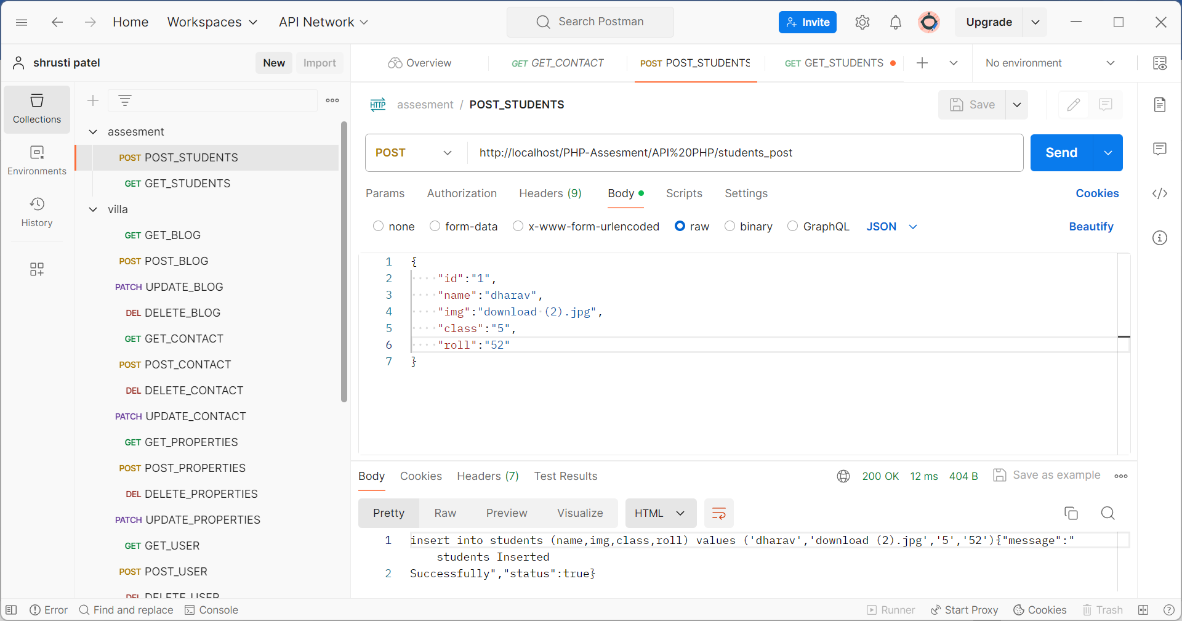

2. Fetch Student Record API:

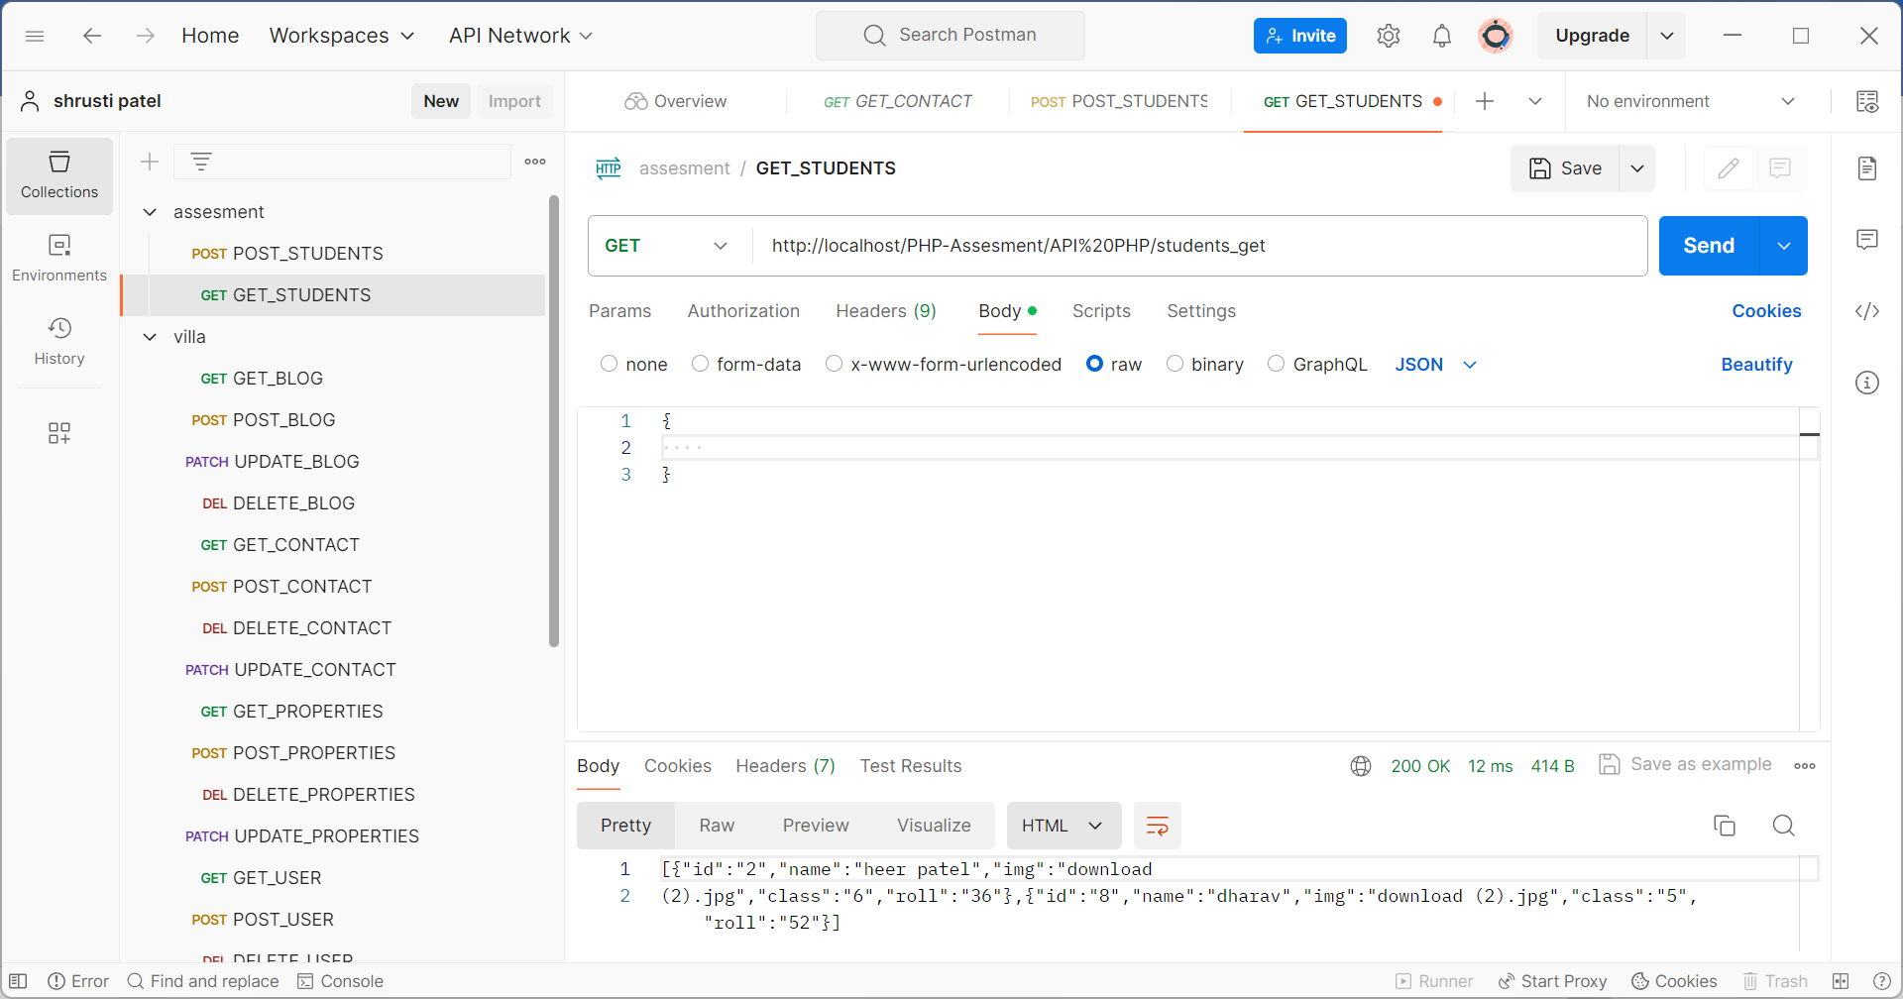

3Update Student API:

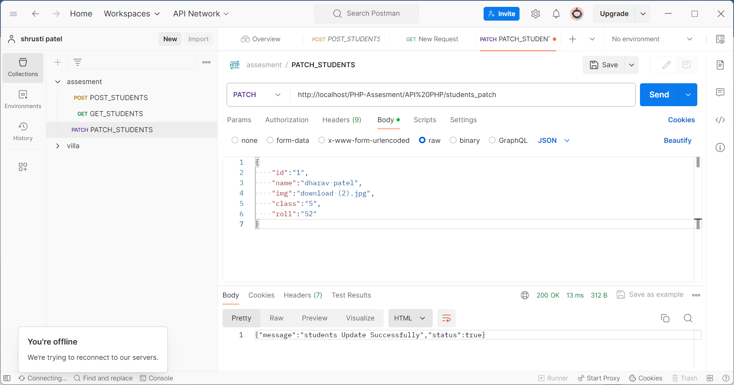

4. Single Student Record Fetch API:



5. Delete Student API:

